Manual Test Plan

1.run GUI

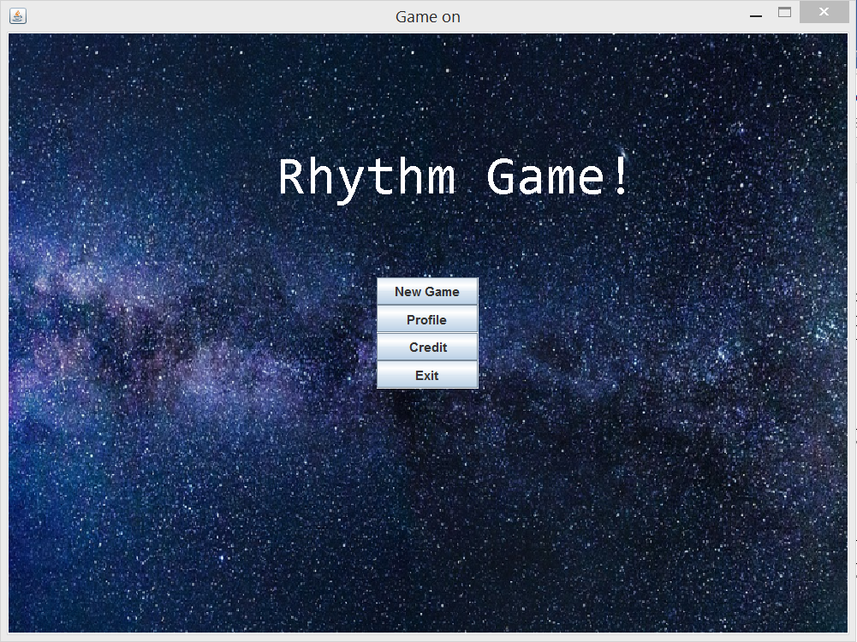

2. New game, back button added. When players hover the mouse curse over two song button, a preview song clip will be played.

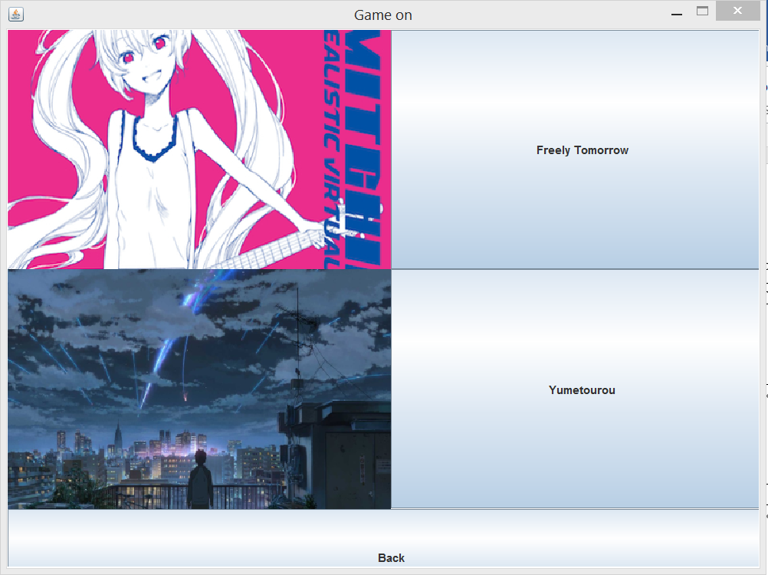

3. Back button added for level selection screen, click Yumetourou.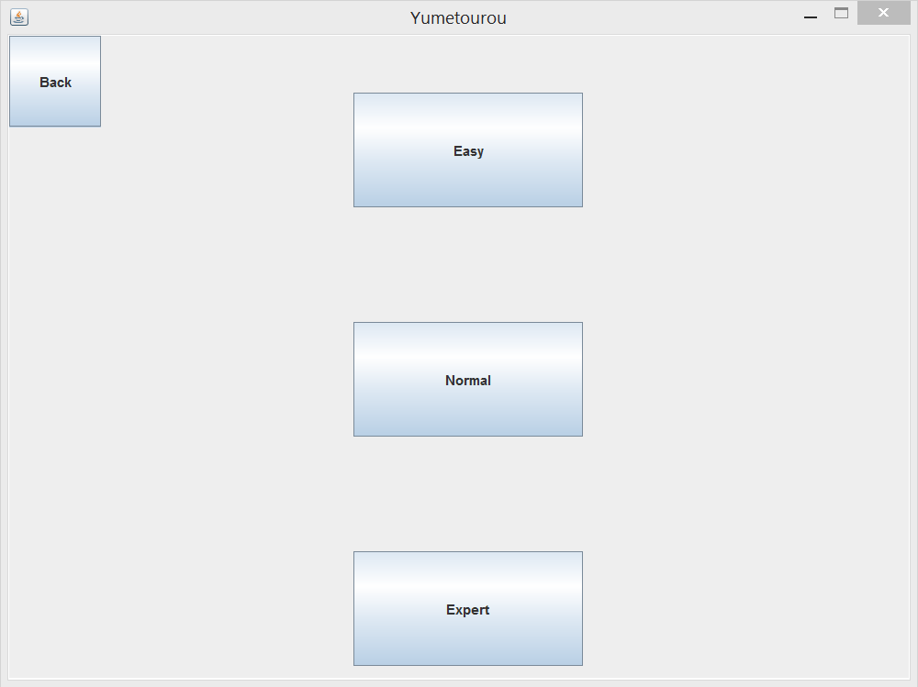

4. Expert, runnable – yellow blocks start falling down, and score gets update when a block is captured by keylistener. One block can only be captured once.

